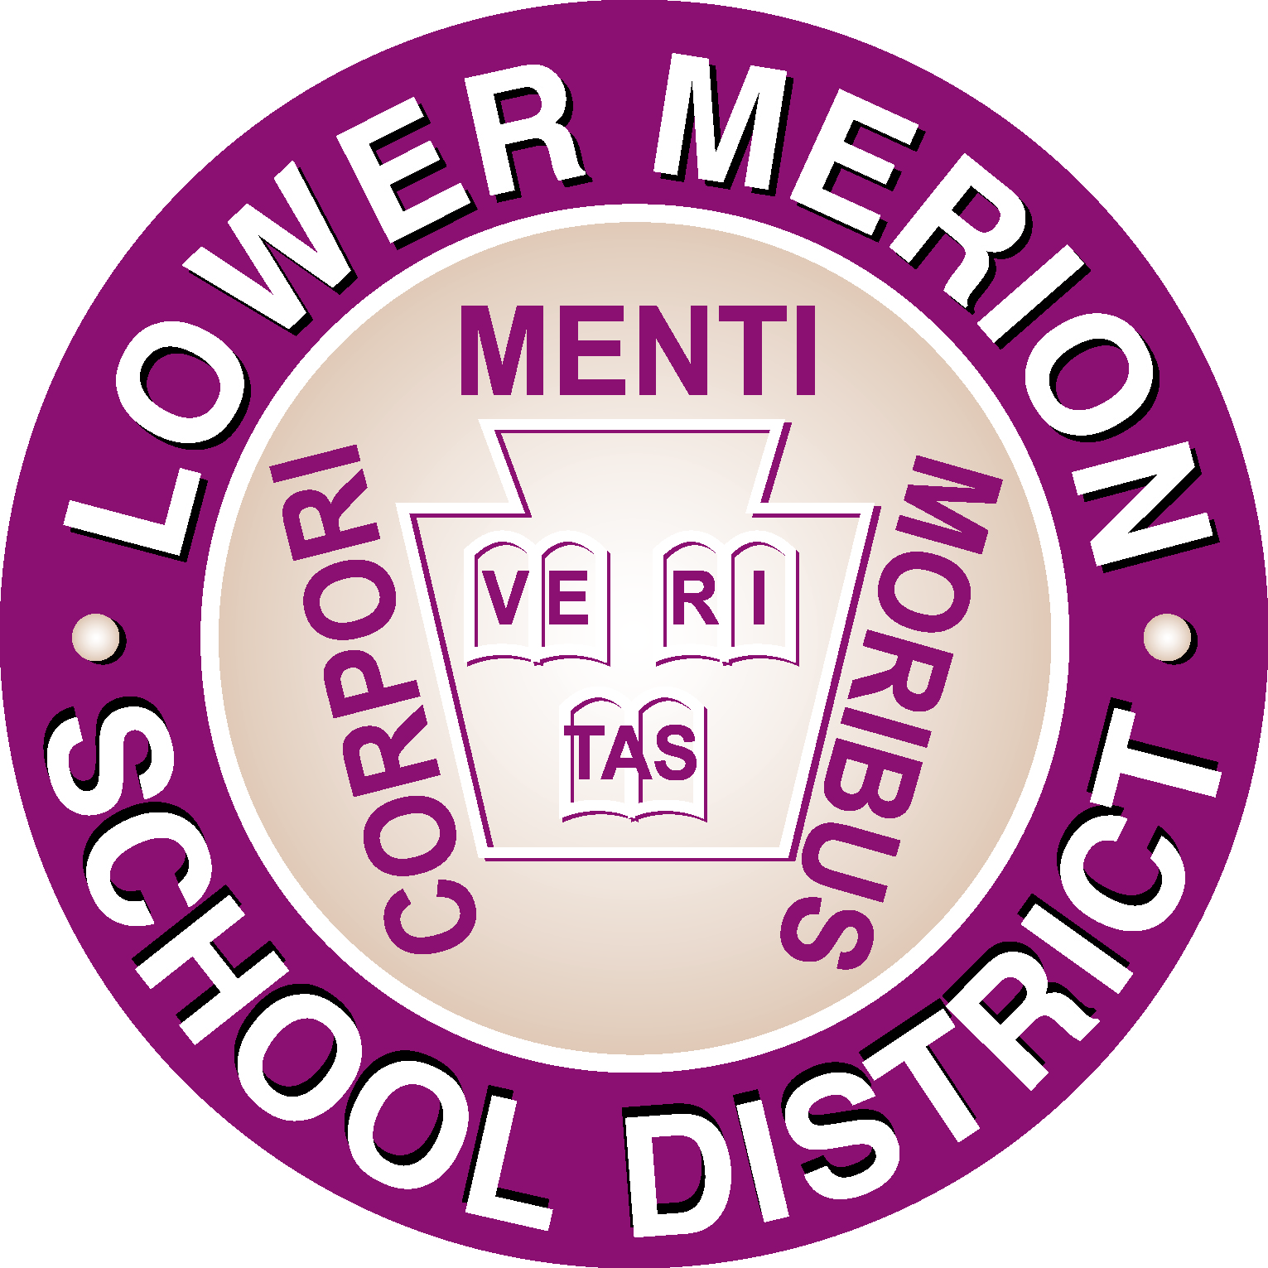
Lower Merion School District

301 East Montgomery Ave. Ardmore, PA 19003-3399
Phone: 610-645-1800 ♦ Fax: 610-645-9679 ♦ www.lmsd.org

SWORN STATEMENT & AFFIDAVIT BY RESIDENT UNDER §13-1302

This portion of the Sworn Statement & Affidavit is to be completed by the Resident Guardian of the child(ren) seeking enrollment in the Lower Merion School District (“District”) and will not be accepted unless properly notarized. One proof of residency must be submitted along with this document.

Name of Child |  | School |  | Grade

Instructions: Please complete the following Sworn Statement & Affidavit if the student is living in a household with more than
one resident adult who will assume responsibility for the student.

This is a legal document. You may ask to see a copy of 24 P.S. §13-1302 prior to signing this document and consult with an attorney if you have any questions or do not understand any portion of this document.

Providing false information in this Sworn Statement is a criminal offense. A person who provides false information shall, upon conviction, be sentenced to pay a fine of up to $300 and/or perform up to two-hundred forty (240) hours of community service, in addition to being required to pay all court costs and the cost of tuition during the period of unlawful enrollment. Tuition is based on the current tuition rate established by the Pennsylvania Department of Education. (2023/2024 rate is/was $130.87 per day, per child). The student will also be removed/expelled from school in accordance with Board Policy.

I, _______________________________________________ do solemnly swear that I reside at
(Resident‘s Legal Name)
_________________________________________________ in the Lower Merion School District and that
(Resident‘s Legal Address)
_________________________________________________ resides here without interruption.
(Child’s Name)

I am a legal owner or lessee of the property _____________________________________________________

Proof of residency is confirmed by: Deed __________ Lease __________ Other ___________

Child’s Date of Birth: ______________________________ Grade: ____________________________________

Name & Address of Last School Attended:

Your relationship to this child, if any:

Effective date of child’s residence in your home?

Will you keep and support the child continuously and not merely through the school term? Yes ____ No ____

Will you assume all personal obligations related to school requirements for this child that may include providing
for required immunizations, uniforms, fees/fines, citations/fines for truancy, attending parent-teacher conferences,
attending meetings/hearings concerning discipline, and fulfilling any special education requirements? Yes ___ No ___

Will you assume the responsibility and obligation for making all education decisions? Yes ______ No ______

SG-1, Rev. 4/2017
AFFIDAVIT OF RESIDENT APPLICANT

Resident applicants should read the below statements carefully and place their initials on the designated line to acknowledge that they (1) understand the statement; (2) affirm that the statement is true and correct to the best of their personal knowledge; and (3) agree to be bound by the terms and conditions of each statement.

_____ I swear/affirm that all of the information contained in the Sworn Statement on the previous page is true and correct to the best of my knowledge.

_____ I represent that I am (1) supporting ___________________________________(“Child”) gratis, without personal gain or compensation; (2) assuming all personal obligations of Child; and (3) intend to keep and support Child continuously, and not merely through the school term.

_____ I understand that I am responsible for immediately notifying the District, within 5 days, of any changes to Child’s living situation, including, but not limited to, moving within or out of the District, or my continued support of Child.

_____ I understand that the District may conduct or cause to be conducted neighborhood observations and/or home visits throughout the year to verify compliance with this Sworn Statement & Affidavit.

_____ I acknowledge and agree that the District may conduct an investigation, now or at any time in the future that this Sworn Statement and Affidavit remains in effect, to verify the accuracy and continued accuracy of the statements contained in this Sworn Statement and Affidavit.

_____ I understand that if it is determined that the statements contained in this Sworn Statement and Affidavit are false, or cease to be true and I failed to immediately notify the District of such change(s), I will be liable to reimburse the District for the tuition cost of educating all children enrolled pursuant to this Sworn Statement and Affidavit for all days of improper attendance at school, including any costs incurred for any investigation or for the collection of tuition. Tuition is based on the current tuition rate established by the Pennsylvania Department of Education (2023/2024 rate is/was $130.87 per day, per child).

_____ I understand that this Sworn Statement and Affidavit expires on June 30 of each year and must be renewed prior to that date in order to continue in effect for the following school year.

_____ I understand that if this Sworn Statement and Affidavit is violated, or if any of the information proves to be false or ceases to be true and I failed to immediately inform the District of such change in circumstances, the District has the right to immediately initiate expulsion proceedings against any child improperly enrolled in the District.

_____ I understand that if this Application and Affidavit is violated, or if any of the information proves to be false or ceases to be true and I failed to immediately inform the District of such change in circumstances, the District may pursue civil proceedings against me for the collection of any applicable tuition and costs, and may refer the matter to the local police and/or the District Attorney’s office for prosecution for unsworn falsification to authorities, theft of services, and/or any other applicable criminal offense.

SG-2, Rev. 4/2017

SWORN STATEMENT & AFFIDAVIT BY RESIDENT UNDER §13-1302
…When a resident of any school district keeps in his home a child of school age, not his own, supporting child gratis as if the child were his own, such child shall be entitled to all free school privileges accorded to resident school children of the district…

Before accepting such child as a pupil, the Board of School Directors of the district may require such resident to file with the secretary of the board, a sworn statement that he is a resident of the district, that he is supporting the child gratis, that he will assume all personal obligations for the child relative to school requirements, and that he intends to so keep and support the child continuously and not merely through the school term.

Section 1302 School Law of Pennsylvania

I have read, understand, and declare that the statements made in this Sworn Statement and Affidavit are true and correct based upon my personal knowledge.

SWORN TO AND SUBSCRIBED
before me this ___________ day
 |  |  |  |  | Signature: |  |  |  | __________________________
of ________________ 20 ____.
 |  |  |  |  | Print Name: |  |  |  | __________________________
_________________________ |  |  |  |  | Phone Number: |  |  |  | __________________________
Notary Public
_________________________ |  |  |  |  | Date: |  |  |  | __________________________
Address
____________________________ |  |  |  |  | ALL APPLICATIONS ARE SUBJECT TO REVIEW.
TO NOTARY PUBLIC
Did identification match above:
  FOR INTERNAL USE ONLY:
  Reviewed by: ___________________________________
  for Lower Merion School District.
  Date: __________
  For attendance purposes,
  this student is: |  | Copy Sent to Central  Registration:
  ______ | Non-Resident |  | ______ | Yes
  ______ | Resident |  | ______ | No
Name |  | ________
Address |  | ________
Signature |  | ________ |  |  | AFFIDAVIT EXPIRES JUNE 30, 2024
 |  |  |  |  | SG-3, Rev. 4/2017

